EMBEDGIT TEAM ONBOARDING GUIDE
Embeddings and
Vector Spaces
A beginner-friendly foundation for semantic search, RAG, vector databases, and our version-control project

Outcome After reading this guide, every teammate should be able to explain what an embedding is, how similarity search works, why vector spaces can become incompatible, and what EmbedGit must track for safe reuse.

SEMESTER PBL | TEAM PRIMER | VERSION 1.0

Start here
This guide assumes no machine-learning background. It starts with intuition, then introduces only the mathematics and engineering ideas needed to work responsibly on EmbedGit.
One-sentence mental model An embedding model converts an item into a list of numbers so that items with related meaning are usually located near one another in a learned vector space.

Learning objectives
- Explain embeddings without using jargon.
- Distinguish tokens, chunks, embeddings, vectors, indexes, and vector databases.
- Compare cosine similarity, dot product, and Euclidean distance at a practical level.
- Describe semantic search and a basic RAG pipeline.
- Recognize when an old embedding is reusable and when it is stale.
- Understand the minimum Python, Git, hashing, testing, and reproducibility knowledge needed before implementation.

The whole pipeline at a glance
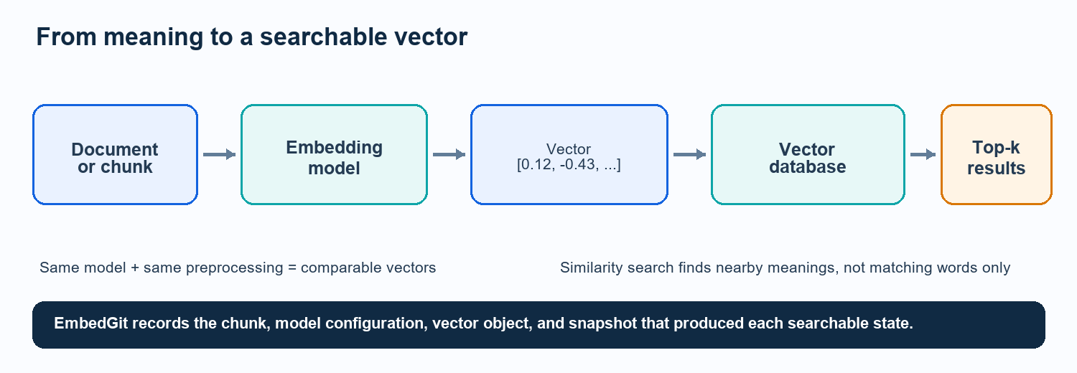
Figure 1. A simplified embedding and search pipeline.
Important The vector does not store a human-readable definition. Its meaning comes from the model, training objective, preprocessing, and the geometric relationships among many vectors.

1. What is an embedding?
An embedding is a numerical representation learned by a model. The input may be a word, sentence, document chunk, image, audio clip, user, or product. The output is a fixed-length vector - an ordered list of numbers.
"process scheduling in operating systems"
-> embedding model
-> [0.12, -0.43, 0.87, 0.05, ...]

Why turn meaning into numbers?
Computers can compare numbers efficiently. A useful embedding model arranges vectors so that semantically related inputs tend to be closer than unrelated inputs. This enables search by meaning instead of exact keyword match.
Input A | Input B | Expected relationship
CPU scheduling | process scheduling algorithms | Very similar
database transactions | ACID properties | Related
computer networks | chocolate cake recipe | Unrelated

Embeddings are learned representations
- They are not manually assigned coordinates.
- Individual dimensions usually do not have a simple label such as 'topic' or 'quality'.
- Quality depends on the model, training data, input language, domain, and task.
- The same text embedded by a different model can produce a completely different vector.
- A vector is useful mainly in relation to other vectors created by a compatible pipeline.
Do not confuse The embedding is the representation. The embedding model is the function that creates it. A vector database stores and searches many such representations.

Tokens, chunks, and embeddings
Term | Meaning | Why it matters
Token | A model-sized unit of text, often part of a word. | Models have token limits and tokenizers differ.
Chunk | A selected segment of a document sent to the model. | Chunk boundaries strongly affect retrieval.
Embedding | The vector produced for one input chunk or item. | It is reused only under compatible configuration.
Metadata | Fields such as source, page, course, or access level. | Filters and provenance depend on it.

2. What is a vector space?
A vector space is the coordinate system in which vectors live. In school mathematics, a point may have two coordinates such as (3, 4). Embeddings use the same broad idea but often have hundreds or thousands of coordinates.
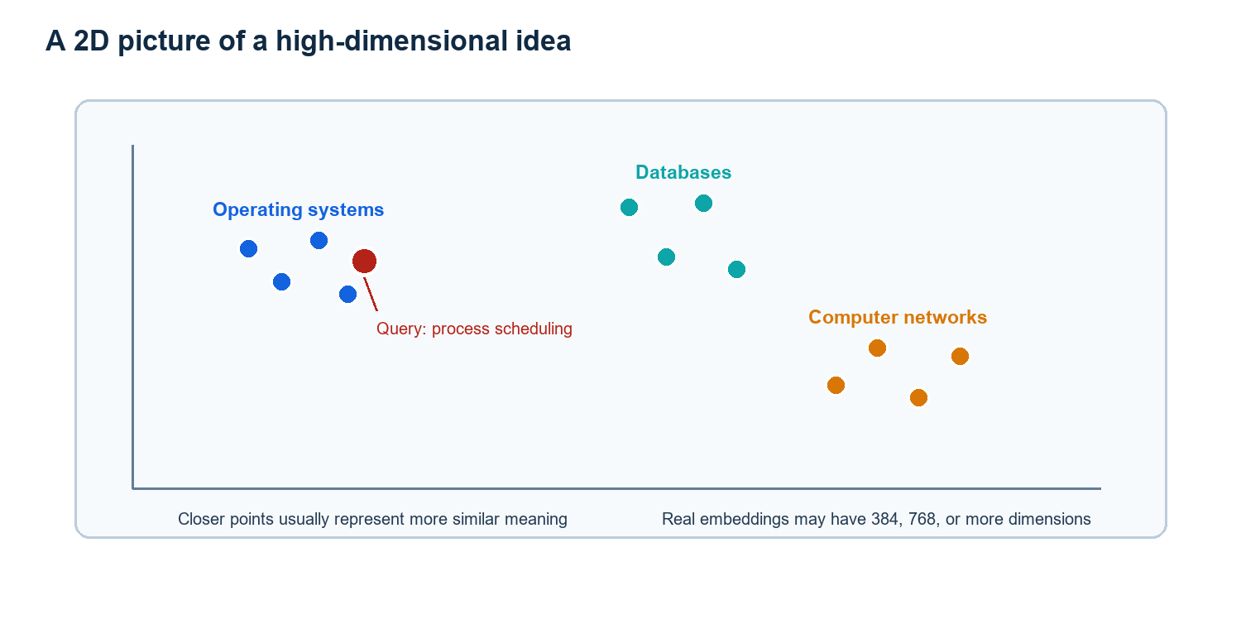
Figure 2. A 2D illustration; real embedding spaces are high-dimensional.
Dimension The dimension is the number of values in a vector. For example, a 384-dimensional model returns exactly 384 numbers for every valid input.

Why high dimensions?
Language contains many overlapping patterns: topic, intent, style, entities, syntax, and context. A high-dimensional space gives a model enough capacity to represent these relationships. We normally do not inspect each dimension separately; we compare complete vectors.

A crucial compatibility rule
Vectors from different models are generally not coordinates in the same space. Equal dimension does not guarantee compatibility. Two 384-dimensional models may arrange meaning differently because they were trained with different data and objectives.
EmbedGit rule A model change is a major version change for the MVP. Existing vectors are marked stale and regenerated rather than mixed blindly with new vectors.

3. How do we compare vectors?
Similarity search compares a query vector with stored vectors and ranks the nearest candidates. The metric must match how the model was designed and whether vectors were normalized.
Metric | Intuition | Typical caution
Cosine similarity | Compares direction; 1 means same direction, 0 means orthogonal. | Magnitude is ignored. Often used for text embeddings.
Dot product | Measures directional agreement and magnitude together. | For unit-normalized vectors it matches cosine ranking.
Euclidean distance | Straight-line distance between points; smaller is closer. | Scale and normalization affect the result.

A tiny worked example
Suppose a normalized query vector is q = [1, 0]. Candidate A = [0.9, 0.1] points in almost the same direction, while candidate B = [0, 1] is perpendicular. Cosine similarity will rank A above B.
cosine(q, A) ~= 0.994
cosine(q, B) = 0.000
Result: A is the more semantically similar candidate.

Nearest neighbours and top-k
The nearest neighbours of a query are its closest stored vectors. A top-k search returns the k highest-ranked candidates, often followed by metadata filtering, reranking, or an application-specific quality check.
- A high similarity score does not prove factual correctness.
- A threshold that works for one model or dataset may fail for another.
- Approximate nearest-neighbour indexes trade a small amount of recall for much faster search.
- Retrieval must be evaluated with labeled queries, not with a few impressive demonstrations.
Normalization L2 normalization scales a vector to length 1. It changes how metrics behave and must be recorded as part of the embedding configuration.

4. How embeddings are created
- Load: Read text and metadata from TXT, Markdown, PDF, or another source.
- Normalize: Apply deterministic rules such as Unicode normalization and whitespace cleanup.
- Chunk: Split content into model-sized, retrieval-friendly segments.
- Tokenize: Convert text into the model's token IDs.
- Run model: Produce hidden representations and pool them into one fixed-length vector.
- Normalize vector: Optionally apply L2 normalization if required by the chosen model.
- Store: Persist the vector with chunk identity, configuration, model revision, and metadata.
- Index: Build or update a structure that supports fast nearest-neighbour search.

Chunking is not a minor detail
A whole textbook chapter may be too broad for a single vector. Very small chunks may lose context. Chunk size and overlap influence retrieval precision, storage, model calls, and change propagation.
Choice | Possible benefit | Possible cost
Large chunks | More context per result | Less precise matches; token limits
Small chunks | Fine-grained retrieval and reuse | Context loss; more vectors
Overlap | Keeps ideas crossing boundaries | Duplicates text and storage
Deterministic IDs | Stable comparisons across runs | Requires careful extraction and normalization

Configuration defines meaning
The model name alone is insufficient. A reproducible configuration should include model revision, tokenizer/library versions, vector dimension, pooling, vector normalization, preprocessing, chunking strategy, chunk size, and overlap.
Project consequence Changing preprocessing or chunking can change chunk hashes. Changing the embedding configuration makes old vectors stale even when the visible text is unchanged.

5. Vector databases and search
A vector database stores vectors and associated metadata, builds an index, accepts a query vector, and returns nearby items. ChromaDB is the MVP backend for EmbedGit.

What a stored record usually contains
{
"id": "chunk-001",
"vector": [0.12, -0.43, 0.87, ...],
"text": "A process scheduler selects ...",
"metadata": {"source": "os/chapter1.pdf", "page": 12},
"embedding_config_hash": "config123"
}

What happens during semantic search
- Embed the user's query with the same compatible model and normalization.
- Optionally apply metadata filters such as course, source, date, or permissions.
- Search the index for approximate or exact nearest neighbours.
- Return top-k records with scores and provenance.
- Optionally rerank or validate results before using them downstream.
Canonical history vs. materialized state For EmbedGit, commit manifests and immutable objects are the version history. ChromaDB is a materialized searchable state that can be synchronized from a selected commit.

Vector index vs. vector database
Concept | Main job | Examples
Vector index | Efficient nearest-neighbour lookup over vectors | HNSW, IVF, flat index
Vector database | Storage, metadata, filtering, persistence, APIs, and indexes | ChromaDB, Qdrant, Milvus, Pinecone, Weaviate

6. Where embeddings are used
Application | How embeddings help | Example
Semantic search | Retrieve conceptually related content despite different wording. | 'deadlock prevention' finds notes about avoiding circular wait.
RAG | Retrieve context for an LLM before answer generation. | Answer a course question using trusted notes.
Recommendations | Match users, products, articles, songs, or courses by learned similarity. | Recommend related learning material.
Clustering | Group nearby vectors without predefined labels. | Organize a large note collection by topic.
Classification | Use embeddings as features or compare with labeled prototypes. | Route support tickets by topic.
Duplicate detection | Find near-duplicate or paraphrased content. | Detect repeated document chunks.
Anomaly detection | Flag items far from known clusters. | Identify unusual transactions or logs.
Multimodal retrieval | Place text and images in related spaces when a model supports it. | Find diagrams using a text query.

RAG: the most relevant project example
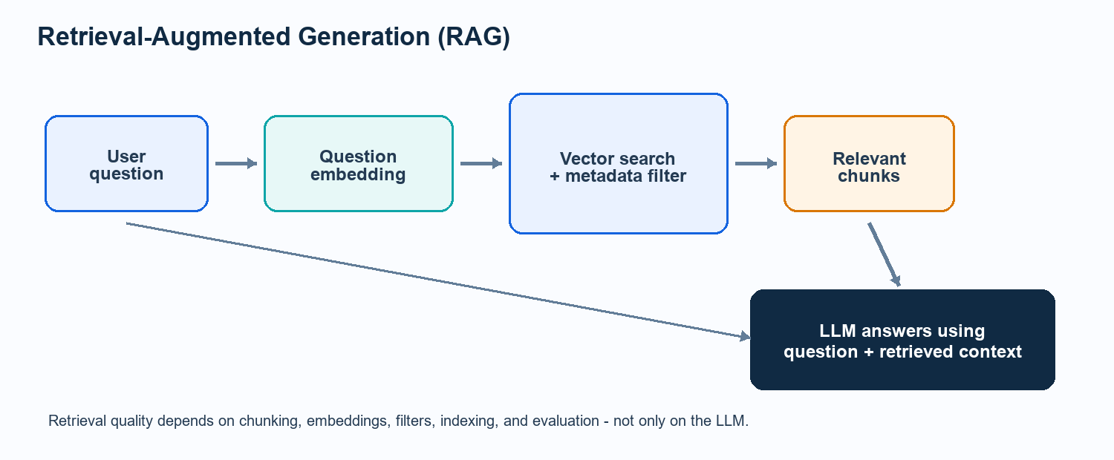
Figure 3. A basic RAG retrieval and generation flow.
Key insight RAG quality is limited by retrieval quality. Poor extraction, chunking, model choice, filtering, or stale vector-store state cannot be repaired reliably by the language model.

7. Why embeddings need version control
Embeddings are derived artifacts. They can become stale when their source, chunk, preprocessing, model, or metadata changes. Rebuilding everything is correct but may be wasteful; reusing everything is cheap but may be wrong. EmbedGit must make that decision explicit and reproducible.

The four states we must keep separate
State | What changes | What EmbedGit records
Source documents | File content or source metadata | Document hash, path, extraction metadata
Chunks | Normalized text or boundaries | Chunk ID, chunk hash, source mapping
Embedding objects | Vector derived from chunk + configuration | Immutable vector object and provenance
Vector-store state | Materialized indexed collection | Which commit is synchronized
Model configuration | Model revision, tokenizer, pooling, normalization | Configuration object and hash

Safe reuse and invalidation
Situation | Classification | Action
Same normalized chunk + same configuration | UNCHANGED | Reuse existing embedding object
Changed or new chunk + same configuration | MODIFIED / ADDED | Generate affected embedding
Same chunk + changed effective configuration | STALE | Regenerate before valid commit
Deleted chunk | DELETED | Remove reference from new manifest and sync
Embedding model changed | MAJOR / EXPERIMENT | Regenerate; do not mix spaces blindly

reusable = (chunk_hash == previous.chunk_hash)
AND (embedding_config_hash == previous.embedding_config_hash)
AND object_integrity_verified
Content-addressable storage Multiple commits can reference the same immutable embedding object. This provides deduplication without calculating textual deltas between floating-point vectors.

8. What to know before coding
Nobody needs to be a mathematician or ML researcher. The team does need a shared baseline in the following areas.
Area | Minimum working knowledge | Why the project needs it
Python | Functions, classes, packages, type hints, file I/O, virtual environments | The CLI, pipeline, storage, and tests are Python.
Git | Repository, commit, branch, checkout, hash, immutable history | EmbedGit adapts these ideas but is not Git.
Basic linear algebra | Vectors, dimensions, distance, dot product, normalization | Needed to reason about similarity and compatibility.
Document pipelines | Loading, parsing, normalization, chunking, metadata | These steps determine chunk identity and reuse.
Hashing | SHA-256 fingerprints, deterministic serialization, collision awareness | Hashes identify content, configuration, and objects.
ML inference | Model vs. training, tokenizer, batch, CPU/GPU, revision pinning | The MVP runs an existing model; it does not train one.
Vector search | top-k, similarity metric, metadata filtering, index | Required for ChromaDB sync and evaluation.
Testing | Unit, integration, fixtures, edge cases, deterministic tests | Restore and reuse errors can silently corrupt results.
Reproducibility | Pinned versions, seeds, environment capture, manifests | A commit should explain how its vectors were produced.

Tools to become comfortable with
- Python 3.11+, virtual environments, pip, and pyproject.toml
- Typer or Click for the command-line interface
- Sentence Transformers for embedding inference
- ChromaDB for persistent vector storage and search
- PyMuPDF for PDF extraction
- Pydantic for validated schemas
- JSON and YAML for manifests and configuration
- Pytest for automated tests
Team rule Pin the embedding model revision and dependency versions before generating benchmark data. Model name alone is not enough for reproducibility.

9. Common misconceptions and failure modes
Misconception | Correct understanding
Each vector dimension has an obvious meaning. | Dimensions are learned and usually interpreted only together.
Same dimension means compatible models. | Two spaces can have equal size but different geometry and semantics.
A high cosine score proves the answer is correct. | Similarity is a retrieval signal, not factual verification.
Only the document filename matters for change detection. | Content, chunks, preprocessing, and configuration determine reuse.
A vector database is the version history. | It is materialized search state; commits and immutable objects are canonical.
A tiny text edit changes only one vector. | Changed chunk boundaries can affect several downstream chunks.
Full regeneration is always wasteful. | It is the correctness baseline, especially after incompatible changes.

Engineering guardrails
- Use deterministic normalization and chunking before optimizing performance.
- Hash canonical serialized configuration, not unordered dictionaries or display text.
- Keep immutable objects separate from mutable refs, cache, and vector-store state.
- Validate object hashes when reading and before restore.
- Make commit creation atomic so partial failures do not advance a branch ref.
- Treat deletion and metadata-only changes explicitly.
- Benchmark full, document-level, and chunk-level regeneration on equivalent final states.
- Evaluate retrieval with labeled queries and report negative results.
- Never commit sensitive source documents or model caches by accident.

What the MVP is not
It is not a new embedding model, not a replacement for Git, not a distributed multi-user service, and not a guarantee that vectors from different models can be aligned. Its contribution is lifecycle management and empirical evaluation.

10. Team kickoff plan
Use this sequence to bring the team to a shared working baseline before dividing implementation work.
Session | Team activity
Session 1 - Concepts | Read sections 1-6 together. Each person explains one concept in their own words.
Session 2 - Mini notebook | Embed 10 short sentences, calculate cosine similarities, and inspect nearest neighbours.
Session 3 - ChromaDB | Insert the vectors with metadata, run top-k queries, and test a metadata filter.
Session 4 - Change experiment | Edit one source paragraph, re-chunk, and identify what should be reused or regenerated.
Session 5 - Design agreement | Freeze MVP schemas, configuration fingerprint, object format, CLI behavior, and test strategy.

Suggested ownership
Workstream | Primary responsibility | Interfaces to agree first
Document pipeline | Loading, normalization, chunking, stable IDs | Chunk schema and configuration
Embedding engine | Model loading, batching, normalization, provenance | Embedding object schema
Repository core | Objects, commits, refs, integrity, checkout | Canonical serialization and hashes
Change detection | Added/modified/deleted/unchanged/stale classification | Reuse and invalidation rules
Vector adapter | ChromaDB materialization, deletion, restore | Commit-to-store synchronization
Evaluation | Datasets, baselines, metrics, reproducible reports | Benchmark manifest and labeled queries

Definition of ready
- Every teammate can explain why same dimension does not imply same vector space.
- The team can calculate or interpret cosine similarity for a toy example.
- Everyone agrees on the four states: sources, chunks/objects, vector-store state, and model configuration.
- The model revision and chunking/preprocessing configuration are pinned.
- Object, commit, and configuration schemas are reviewed before implementation.
- A small golden test corpus and labeled query set exist.
- Baseline commands and expected final-state checks are written down.
Recommended first milestone Build a vertical slice for 3-5 text files: init -> add -> status -> embed -> commit -> search -> modify one paragraph -> incremental commit -> diff -> checkout.

11. Quick-reference glossary
Term | Plain-language meaning
Embedding | A learned numerical representation of an item.
Vector | An ordered list of numbers; the output representation.
Vector space | The coordinate system in which compatible vectors can be compared.
Dimension | The number of values in each vector.
Cosine similarity | A comparison of vector direction, often used for text.
Nearest neighbour | A stored vector closest to a query under the selected metric.
Top-k | The k highest-ranked search results.
Chunk | A deterministic document segment embedded as one unit.
Tokenizer | The component that turns input text into model token IDs.
Pooling | The method used to combine model outputs into one vector.
Normalization | Text cleanup or vector scaling; both must be specified clearly.
Vector database | A system that stores, filters, indexes, and searches vectors.
RAG | Retrieval-Augmented Generation: retrieve context, then generate an answer.
Content-addressable | Identified by a hash of content rather than a mutable name.
Stale | No longer valid under the current effective configuration.
Provenance | Evidence describing where data came from and how it was produced.

Knowledge check
- Why can two 384-dimensional models still be incompatible?
- When may EmbedGit safely reuse an embedding object?
- What is the difference between a chunk and an embedding?
- Why is ChromaDB not the canonical version history?
- What changes when chunk size changes?
- Which metrics should compare retrieval quality across commits?
Answer checkpoint A teammate is ready to start implementation when they can answer these questions using the terms model configuration, deterministic chunking, immutable object, commit manifest, and retrieval evaluation.

Final takeaway
Embeddings make meaning computationally comparable. Vector spaces make similarity search possible. Reliable systems must preserve the exact relationship between source content, chunks, model configuration, vectors, and searchable database state. That relationship is the core of EmbedGit.

